Template of abstract for the 10th IWLiME, October 23th-25th, 2023 (place your title here, Times New Roman 18 centered)

A. Firstauthor¹, B. Secondauthor², C. Thirdauthor¹, D. And So On² (Times New Roman 12, normal, centered. Presenting author underlined)
¹Center for Advanced Research in Lithium and Industrial Minerals, University of Antofagasta, Avenue Universidad de Antofagasta 02800, Antofagasta, Chile.
²Chemical Engineering Department, University of Antofagasta, Avenue Universidad de Antofagasta 02800, Antofagasta, Chile

1-2 pages abstracts should be submitted to the 10th IWLiME, before August 28th, 2023. Abstracts should be submitted directly through the congress email: IWLiME@outlook.com.

Submitted abstracts will be reviewed by the Scientific Committee. Acceptance will be notified to the author within September 1st, 2023.
The abstract of the contributed papers must be in English and should report previously unpublished work. The authors are responsible for the content and style of the contribution. No editing or re-typing will be carried out by the workshop organizers.
The contributions will be reproduced without reduction or modification. The required styles illustrated in this document must be used as a template for producing the abstract, replacing the relevant text with your own. The main types of fonts used are shown in Table 1.

The submitted file must be a MS Word document: .docx.
The abstract should be typewritten for letter format paper (21.59 × 27.54 cm). Top and bottom margins should be set to 2.5 cm, left to 2.5 cm and right margins to 2 cm. Single-line spacing should be used.
Papers may include figures and tables. The figures must be centered, have good resolution to be properly viewed. Figures and tables must be made to be standalone. A caption should be written under each figure and above each table, and they must be mentioned in the main text. Examples are shown in Figure 1 and Table 1.
Three to five keywords must be given below the main text. The references must be mentioned as
shown. [1]

Table 1 Type of fonts used in the abstract
Section | Font | Size | Style
Title | Times New Roman | 18 | Normal
Author | Times New Roman | 12 | Normal
Affiliations | Times New Roman | 10 | Italic
Main text | Times New Roman | 12 | Normal
Figures and tables caption | Times New Roman | 12 | Normal
Acknowledgements | Times New Roman | 12 | Italic

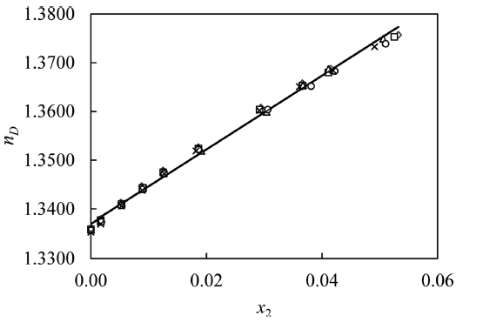
Figure 1. Refractive Index n_{D} of aquoues solutions of lithum sulfate saturated in boric acid as a function of lithium sulfate mole fraction, x_{2;} this study (◇, T = 293.15 K; □, T = 298.15 K, Δ, T = 303.15 K, ○, T =308.15 K, × , T = 313.15 K); −, calculated from eq 5. Ref: Alavia et al.[2]

Keywords: Style, Times New Roman, Deadline

Acknowledgments: Times New Roman 12

References:
[1] P. Author, S. Author, Title, Journal Title, Volume (year).
[2] W. Alavia, J. Lovera, B. Cortez, T. Graber, Solubility, Density, Refractive Index, Viscosity, and Electrical Conductivity of Boric Acid + Lithium Sulfate + Water System at (293.15, 298.15, 303.15, 308.15 and 313.15) K. J. Chem. Eng. Data, 86 (2013) dx.doi.org/10.1021/je400086a.

